Lab 03 Remote Sensing in the Geosciences

Arielle Wood

Part 1

Band 2:

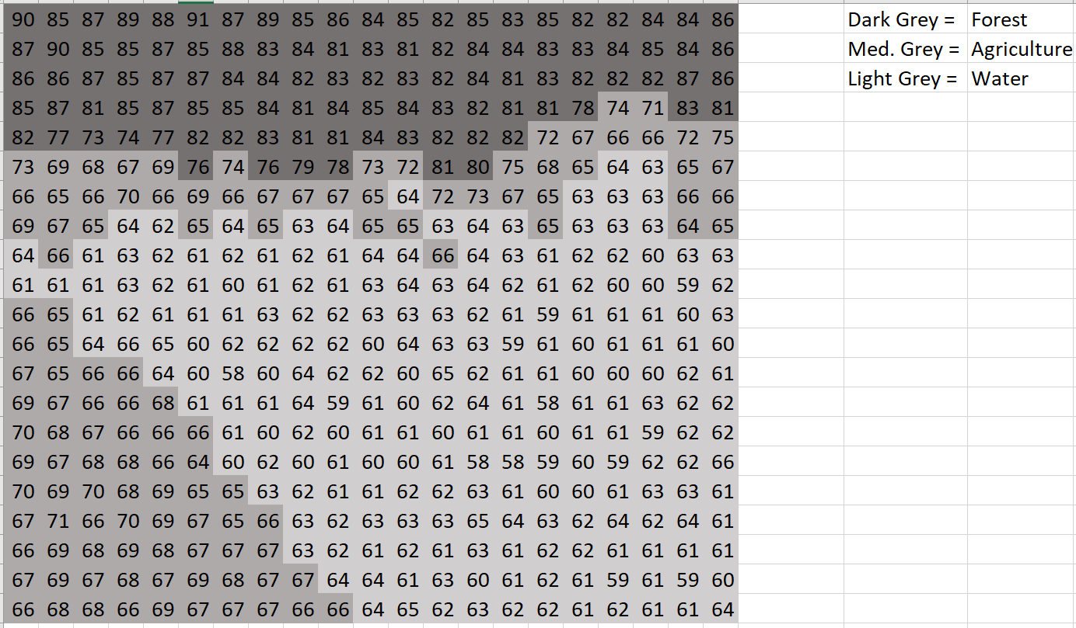

Band 3:

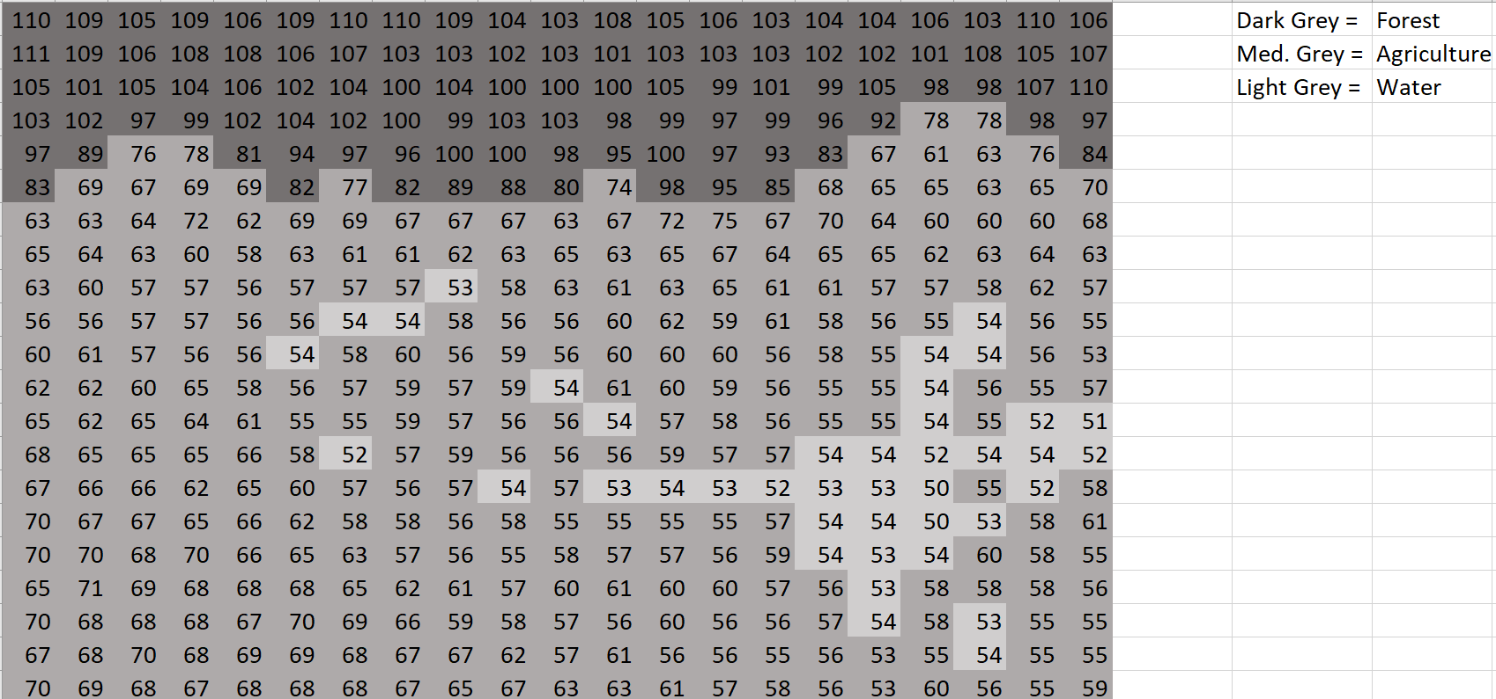

Band 4:

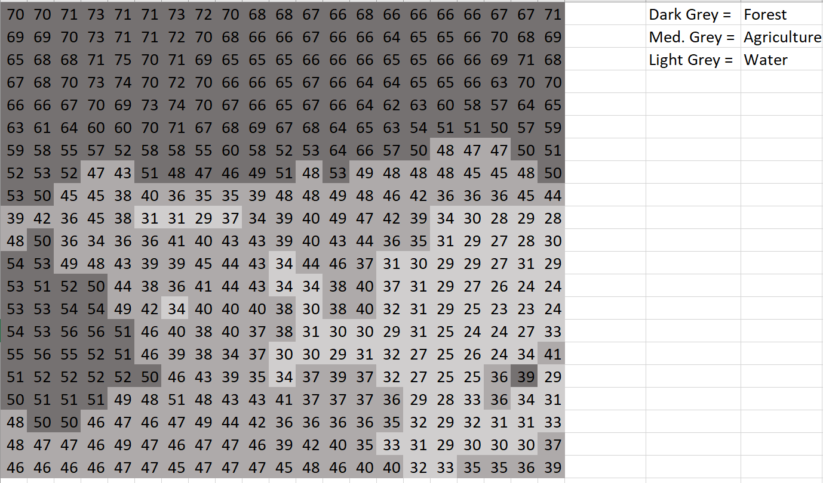

1. Band 2 is closer to band 3 in terms of the forest and agriculture depicted areas. This is because band 2 reflects leafy green surfaces while band 3 absorbs green chlorophyll. They both relate to green vegetation surfaces.

2. Band 3 showed the highest amount of variation within the BV numbers. The numbers ranged from 110 to 51. This shows a range of 59.

3. Band 4 shows the most variation in terms of land cover types. This is due to a large amount of variation.

4. For band 2, my manual classification fits the actual data relatively well. Where there are moments of high reflectance in the actual raster, there are moments of high reflectance in my manual classification. For band 3, my manual classification does not fit the actual raster as well as it could. My high reflectance area accurately characterizes that of the actual raster, yet my areas of low or medium reflectance do not accurately match that of the actual image. For band 4, my manual classification almost perfectly fits that of the actual image. My high reflectance areas match that of the image, along with my low and medium reflectance areas.

5. Forest cover is the most difficult to visualize within the visual image display.

6. Band 3 has the clearest discrimination between land cover types. Band 2 has the least clear discrimination between land cover types.

Color Composite:  


Color Infrared:



Do either of these land-cover types improve your capability to visually discriminate among various land-cover types?

The color infrared helps to discriminate some land cover types, but is still not very clear as to changes between the land cover types. It offers more clarity than the color composite, but it still somewhat lacking on detail in terms of differentiating land cover types.

Part 2

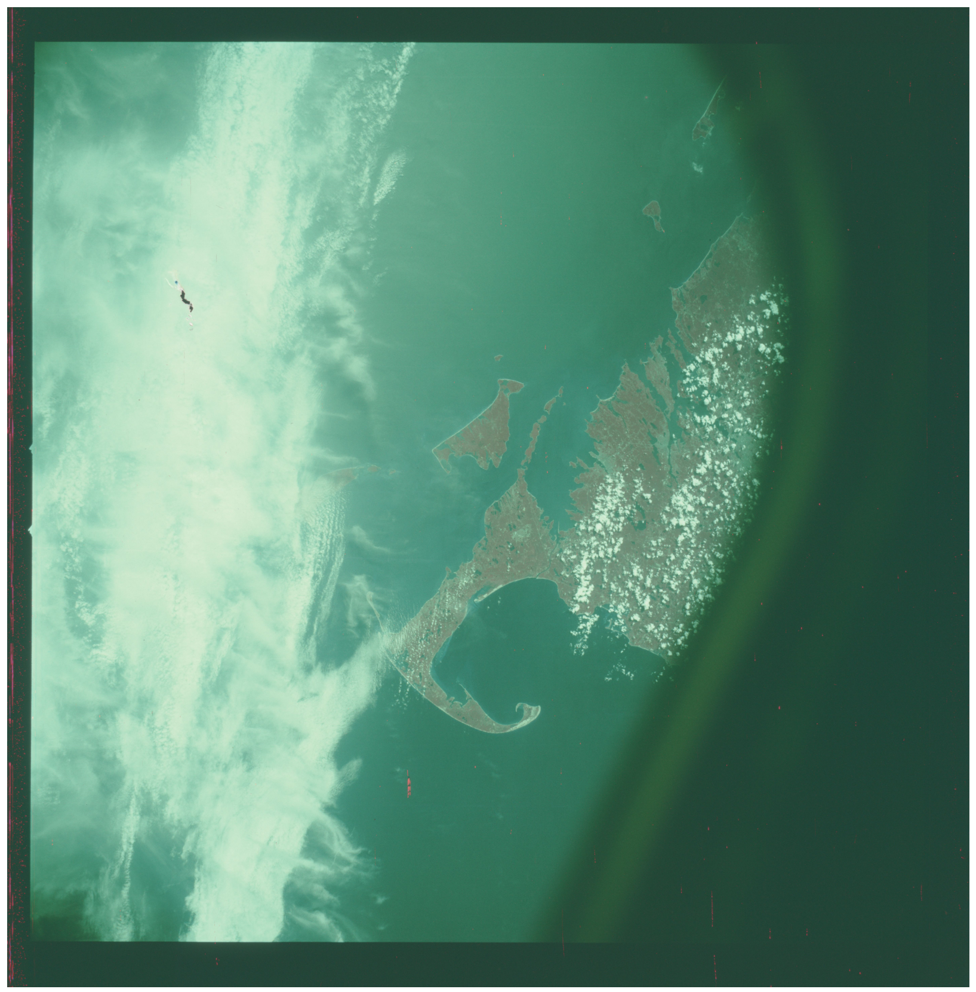

Part 3

